17.80: All linear dimensions of the hoop are increased by the same factor of 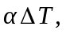 so the increase in the radius of the hoop would be

